
INSTITUT KEMAHIRAN MARA LUMUT, PERAK

DIPLOMA IN COMPUTER TECHNOLOGY (BIG DATA) SEMESTER 4
JANUARY – JUNE 2026

MOBILE APPLICATION DEVELOPMENT
DFD 40143

PREPARED BY:
NUR FADHILATUL AKMA BINTI ROSLAN 2402083

PREPARED FOR:
MOHD SHUKRI BIN MUHAMAD HUSIN

DATE OF SUBMISSION: 26 JANUARY 2026
TABLE OF CONTENTS
Contents
- INTRODUCTION 3
- PROBLEM STATEMENT 6
- OBJECTIVES 7
- UX REVIEW OF THE MOBILE APPLICATION 8
- WIREFRAME DESIGN 9
- PERFORMANCE AND FUNCTIONALITY COMPARISON 10
- USER PREFERENCES SURVEY 12
7.1 SURVEY DISTRIBUTION 12
7.2 METHODOLOGY 14
7.3 SURVEY FINDING 15
7.4 ANALYSIS AND DISCUSSION 24
7.5 RECOMMENDATIONS 25
- CONCLUSION 26
- REFERENCES 27

LIST OF FIGURES

- Figure 1: Fixora logo
- Figure 2: Fixora wireframe design
- Figure 3: Fixora Survey Introduction Page
- Figure 4: Google form
- Figure 5: Whatsapp
- Figure 6: Gender Distribution of Survey Respondents
- Figure 7: Age Group Distribution of Survey Respondents
- Figure 8: Primary Device Used by Respondents
- Figure 9: Frequency of Laptop/PC Maintenance Among Respondents
- Figure 10: Device Performance Issues
- Figure 11: Confidence Level in Maintaining Devices
- Figure 12: Awareness of Safe Device Cleaning Methods
- Figure 13: Data Privacy Concerns
- Figure 14: Main Challenges in Maintaining Devices
- Figure 15: Experience of Data Loss Due to Device Issues
- Figure 16: Actions Taken by Users During Device Slowdowns
- Figure 17: Expected Usefulness of the Fixora App
- Figure 18: Demand for Simple Device Fixes App
- Figure 19: Interest in Learning Advanced Tips
- Figure 20: Need for a Maintenance App
- Figure 21: Confidence Increase with App Support
- Figure 22: Willingness to Recommend the App

INTRODUCTION

With the increasing reliance on laptops and PCs for education, work, and daily activities, proper device maintenance has become increasingly important. However, many users still face common problems such as slow system performance, overheating, and a lack of basic knowledge on how to maintain their devices correctly. These issues can lead to reduced device lifespan, frequent breakdowns, and higher repair costs.
To address these challenges, Fixora is introduced as an educational mobile application that focuses on laptop and PC maintenance. The app is designed to help users understand and manage common device issues by providing clear, practical, and easy to follow maintenance tips. Through simple guidance and troubleshooting information, Fixora aims to improve user’s awareness of proper device care and support them in maintaining their devices safely and effectively in a user-friendly environment.

App Name

The mobile application is named Fixora. The name comes from the word “fix,” which shows the app’s purpose of helping users maintain and repair their laptops and personal computers, combined with “-ora” to make it unique and easy to remember. Fixora is designed to be simple and suitable for users with different levels of technical experience. The name also reflects reliability and user-friendliness, matching the app’s goal of providing practical maintenance tips in an easy-to-understand way.

Logo Concept
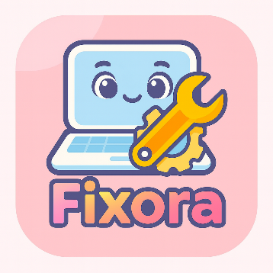
Figure 1: Fixora logo

The logo concept for Fixora focuses on simplicity and clarity. Soft pastel colors are used to create a calm and approachable appearance, representing care, reliability, and ease of use. Visual elements such as a laptop, gear, or wrench may be incorporated to clearly indicate the app’s function related to device maintenance. The overall design aims to establish trust and make the app visually appealing to users.

Main Features

Fixora focuses on providing practical guidance that can be easily understood by users. The main features of the app include:
- Maintenance Tips and Guides
Provides simple and step-by-step instructions to help users perform basic maintenance on their laptops and PCs.
- Problem-Solving Tutorials
Offers guidance on how to troubleshoot common device problems such as overheating, slow performance, and storage management.
- Video Learning Section
Includes short tutorial videos to support visual learning and enhance user understanding of maintenance processes.

These features are designed to help users maintain their devices independently and reduce unnecessary visits to repair shops.

Technology Considerations

Fixora will be developed as a native Android mobile application. This approach allows the app to be optimized specifically for Android devices, ensuring better performance and compatibility. It is chosen because most target users use Android smartphones, and native development makes the app easier to develop, test, and maintain.

Monetization Plan

The monetization strategy for Fixora will include in-app advertisements and optional premium features. Basic maintenance information will be provided free of charge, while advanced tips and exclusive learning content may be offered through premium access. This approach allows the app to remain accessible while ensuring sustainability.

PROBLEM STATEMENT

In an increasingly connected world, laptops and personal computers are increasingly used by students and working individuals. With this growing reliance, device maintenance has become an important concern. However, many users lack basic knowledge on how to properly maintain their devices, which often leads to common issues such as slow system performance, overheating, and reduced device lifespan.
Most users depend heavily on repair shops or online forums when problems occur, which can be time-consuming and sometimes costly. In addition, available information on device maintenance is often scattered across different platforms and may be difficult for beginners to understand.
Therefore, there is a need for a simple and user-friendly mobile application that provides clear maintenance tips, problem-solving guidance, and educational resources in one platform. This problem motivates the development of Fixora, a mobile application designed to help users maintain their laptops and PCs more effectively and safely.

OBJECTIVES

The main objective of Fixora is to provide users with a practical and easy-to-use platform for maintaining their laptops and personal computers. The app aims to improve users’ knowledge and awareness of proper device care, helping them prevent common problems such as slow performance, overheating, and data loss. Fixora also seeks to offer step-by-step guides, tutorials, and visual learning resources, including videos, to make device maintenance more accessible, even for users with limited technical experience.
Additionally, the app is designed to allow users to track their device maintenance habits, check which maintenance tasks are needed, and learn tips for improving their device’s performance and lifespan. By centralizing maintenance information and guidance in one application, Fixora reduces users’ reliance on repair shops and scattered online resources. Ultimately, the app aims to empower users to take control of their device maintenance, encourage safe and efficient usage habits, and provide a reliable tool that can be referred to whenever maintenance is needed.

UX REVIEW OF THE MOBILE APPLICATION

The Fixora mobile application is designed with a simple and clean layout to ensure ease of use for users. The interface uses a well-organized layout where information is arranged clearly, making it easy for users to read and understand the content. Important sections are placed logically so users can access them without confusion.
The app uses soft and neutral colors to create a comfortable viewing experience. These colors help reduce eye strain and make the app suitable for daily use. Simple and readable fonts are used to ensure that text is clear and easy to read for users of different ages and technical backgrounds.
Icons in the app are simple and meaningful, helping users quickly recognize functions such as maintenance tips, tutorials, and video guides. The navigation in the app is straightforward, allowing users to move between different sections easily. Menus and buttons are clearly labelled, which helps users find features without spending too much time searching.
Overall, Fixora provides a user-friendly experience. The simple design and easy navigation make the app suitable for users with limited technical knowledge. This helps users feel more confident when using the app to learn basic laptop and PC maintenance.

WIREFRAME DESIGN

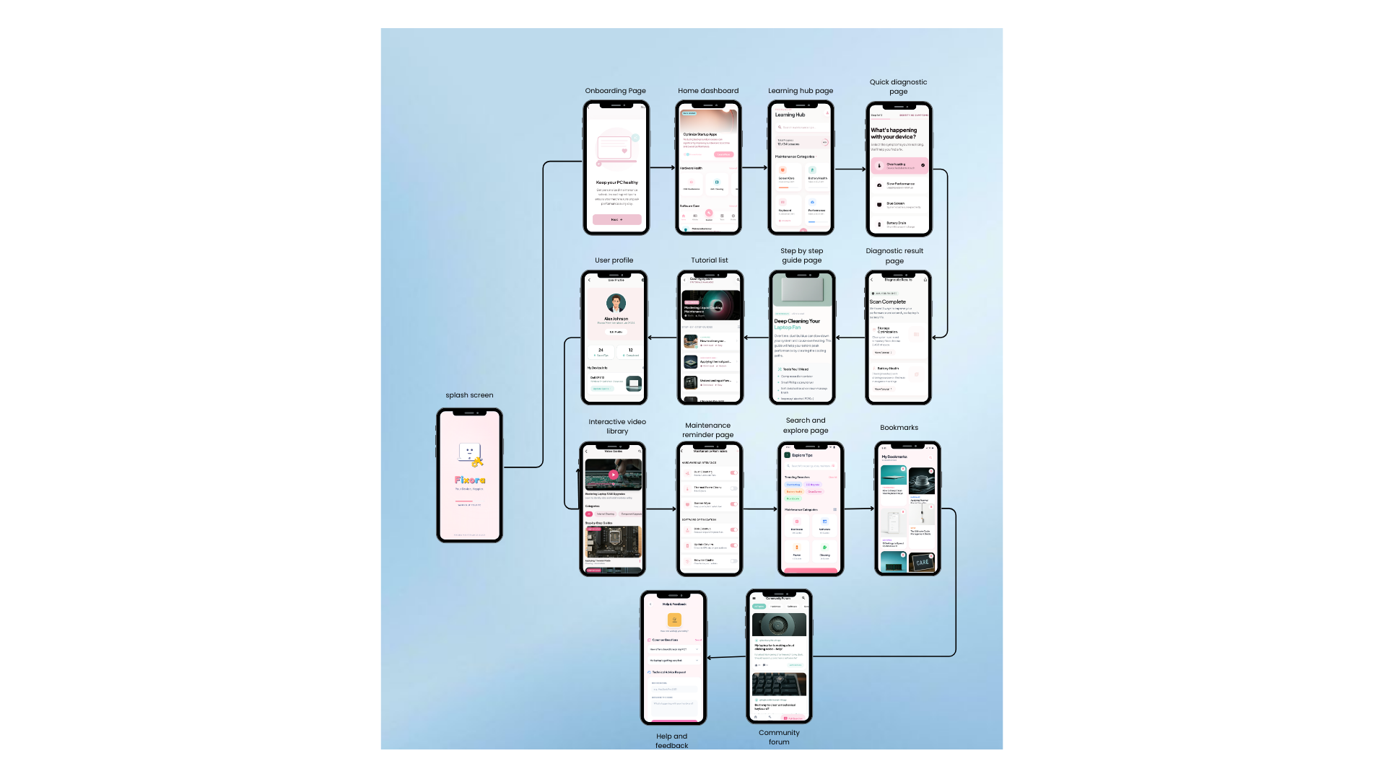
Figure 2: Fixora wireframe design

PERFORMANCE AND FUNCTIONALITY COMPARISON

App Performance

One of the main strengths of Fixora is its reliable performance due to the native Android development approach. The app has better access to device features such as storage, notifications, and media playback, which helps improve functionality. Fixora also has a simple and user-friendly interface, making it easy for users with different levels of technical knowledge to understand and use the app. The content focuses on practical maintenance tips and common problem solutions, which can help users take better care of their laptops and PCs without depending too much on repair shops. In addition, the use of visual guides and videos makes learning more effective and easier to follow.

Strengths
One of the main strengths of Fixora is its reliable performance due to the native Android development approach. The app has better access to device features such as storage, notifications, and media playback, which helps improve functionality. Fixora also has a simple and user-friendly interface, making it easy for users with different levels of technical knowledge to understand and use the app. The content focuses on practical maintenance tips and common problem solutions, which can help users take better care of their laptops and PCs without depending too much on repair shops. In addition, the use of visual guides and videos makes learning more effective and easier to follow.

Weaknesses
Despite its strengths, Fixora has some limitations. Since the app is developed only for Android, it is not accessible to iOS users. This limits the number of potential users. If the app is expanded in the future, additional development would be required to support other platforms. Another weakness is that the app mainly provides guidance and tips, so its effectiveness depends on user motivation and willingness to follow the instructions. Without regular engagement, users may not fully benefit from the app. However, these weaknesses can be improved in future versions through platform expansion and added interactive features.

USER PREFERENCES SURVEY

SURVEY DISTRIBUTION

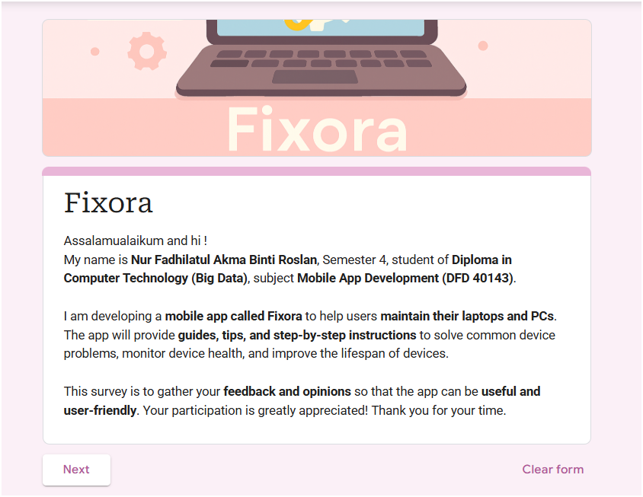
Figure 3: Fixora Survey Introduction Page

The survey was designed to gather insights into users’ habits, challenges, and expectations regarding laptop and PC maintenance. It consisted of fifteen structured questions covering several key areas. Respondents were first asked about the type of device they primarily use laptop, PC, or both and the frequency of their regular maintenance routines. The survey also explored common issues, such as overheating or slow performance, and the level of confidence users have in maintaining their devices independently. Questions were included to assess knowledge of safe cleaning practices, concerns about data privacy when sending devices to repair shops, and the main challenges faced in device upkeep, such as lack of knowledge, lack of time, or fear of causing damage. Additionally, participants were asked whether they had ever lost important data due to device problems and how they typically respond when their device slows down.

To evaluate interest in potential solutions, the survey introduced the concept of a maintenance app, Fixora, and asked respondents about its perceived usefulness, their willingness to follow step-by-step instructions, and their interest in learning advanced tips to extend device lifespan. Finally, the questionnaire measured whether users believe such an app is necessary, whether it would increase their confidence in maintaining their devices, and if they would encourage others to use it. Overall, the survey aimed to capture both practical experiences and attitudes toward a dedicated maintenance application, providing valuable feedback to support the development of Fixora.

METHODOLOGY


Figure 4: Google form

This study used Google Forms to create a questionnaire with seventeen multiple-choice questions. The survey aimed to gather information on users’ laptop and PC usage, maintenance habits, common challenges, and interest in a maintenance app. Clear instruction and an introduction were included to help participants understand the purpose of the survey. The link was shared with at least 30 respondents through messaging apps and social media. Participation was voluntary and responses were collected anonymously. The data was then summarized and presented using simple bar and pie charts to clearly illustrate key findings and user preferences.


Figure 5: Whatsapp

To reach respondents efficiently, the survey link was distributed via WhatsApp, which allowed quick sharing among friends, family members, and potential users. This ensured convenient access and encouraged participation. In total, 30 responses were collected, with participation being voluntary and anonymous. The data gathered through Google Forms was then summarized and visualized using bar charts and pie charts to highlight user preferences and key findings

SURVEY FINDING

Question 1:
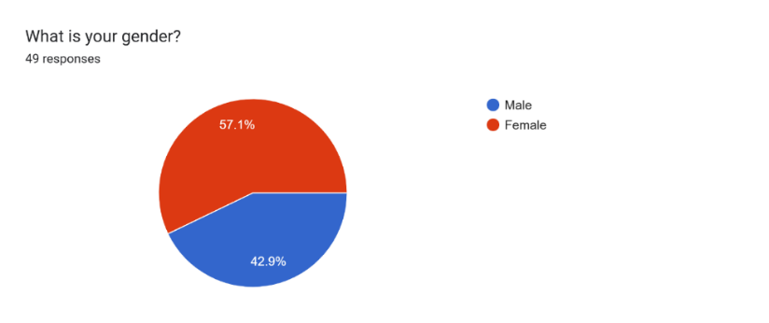
Figure 6: Gender Distribution of Survey Respondents

The pie chart shows the gender distribution of 49 survey respondents. Among them, 57.1% are female and 42.9% are male. This means there were slightly more female participants compared to male. The chart uses red to represent females and blue to represent males, making it easy to see the overall demographic composition of the group.

Question 2:
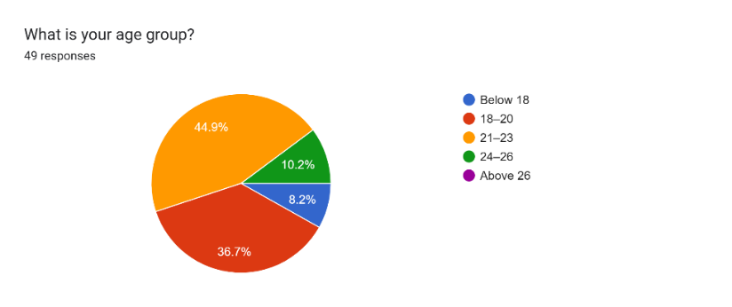
Figure 7: Age Group Distribution of Survey Respondents

The pie chart shows the age distribution of 49 survey participants. The largest group falls within the 18–20 age range, making up 44.9% of the total. This is followed by 21–23 years old at 36.7%, and 24–26 years old at 10.2%. A smaller portion, 8.2%, are below 18. No respondents were recorded in the above 26 category. This age breakdown helps identify the main target audience for the app, which consists mostly of young adults between 18 and 23 years old.
Question 3:
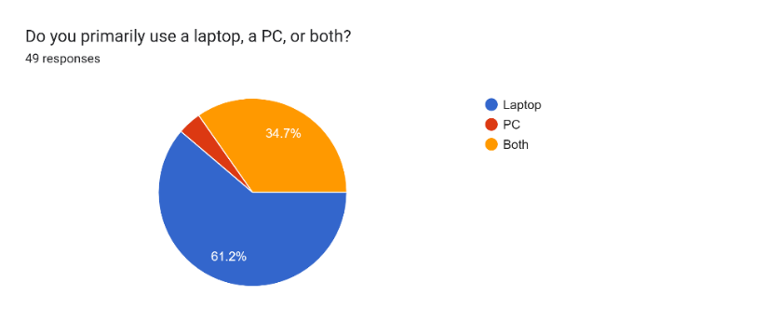
Figure 8: Primary Device Used by Respondents

The pie chart shows which type of device respondents primarily use. Out of 49 responses, 61.2% use a laptop, 34.7% use both a laptop and a PC, while only a small portion use PC only. This indicates that most users rely on laptops, either alone or alongside a PC. Understanding this helps ensure the app is optimized for laptop users, who form most of the target audience.

Question 4:
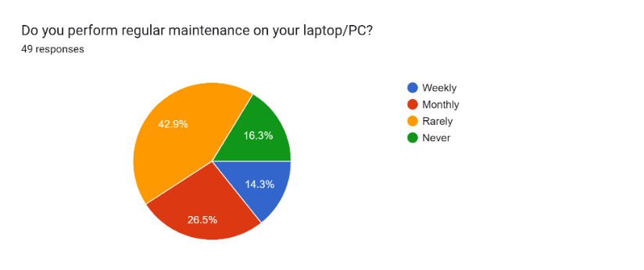
Figure 9: Frequency of Laptop/PC Maintenance Among Respondents

The pie chart shows how often respondents perform maintenance on their devices. Out of 49 responses, 42.9% said they rarely maintain their laptop or PC, while 16.3% never do it at all. Meanwhile, 26.5% perform maintenance monthly, and only 14.3% do it weekly. This suggests that most users do not maintain their devices regularly, which highlights the need for a helpful and easy-to-use maintenance app.

Question 5:
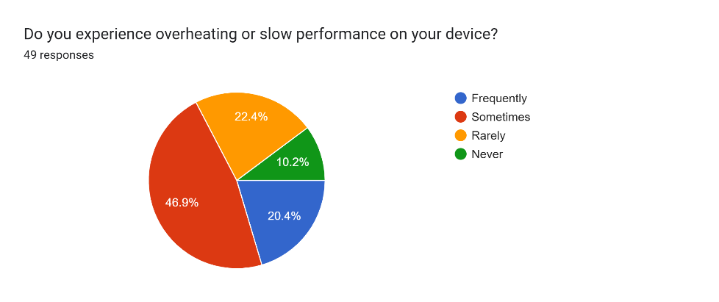
Figure 10: Device Performance Issues

This pie chart shows how often users experience overheating or slow performance on their devices. Out of 49 responses, 46.9% said they sometimes face these issues, while 20.4% experience them frequently. Meanwhile, 22.4% rarely encounter problems, and 10.2% never do. This means most users deal with performance issues at least occasionally, which supports the need for a solution that helps improve device speed and stability.

Question 6:
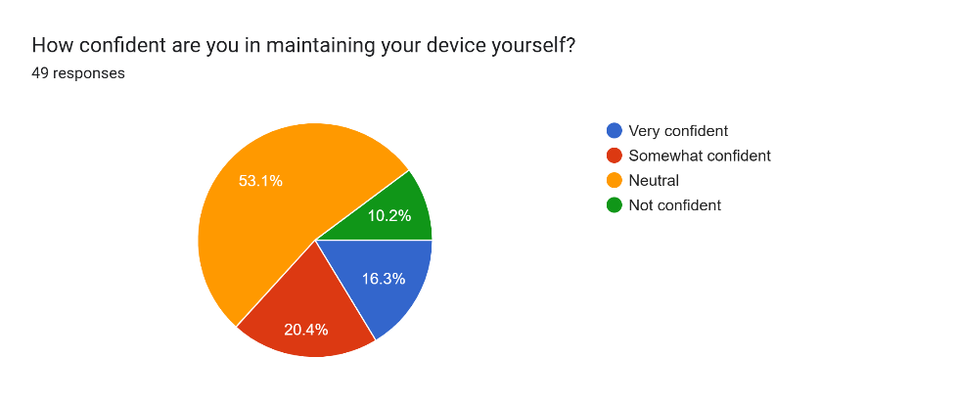
Figure 11: Confidence Level in Maintaining Devices

The pie chart shows how confident users feel about maintaining their own laptops or PCs. Out of 49 responses, 53.1% said they are somewhat confident, while 16.3% feel very confident. Meanwhile, 20.4% chose neutral, and 10.2% said they are not confident. This suggests that most users have some level of confidence, but many may still need guidance or support when it comes to device maintenance.

Question 7:
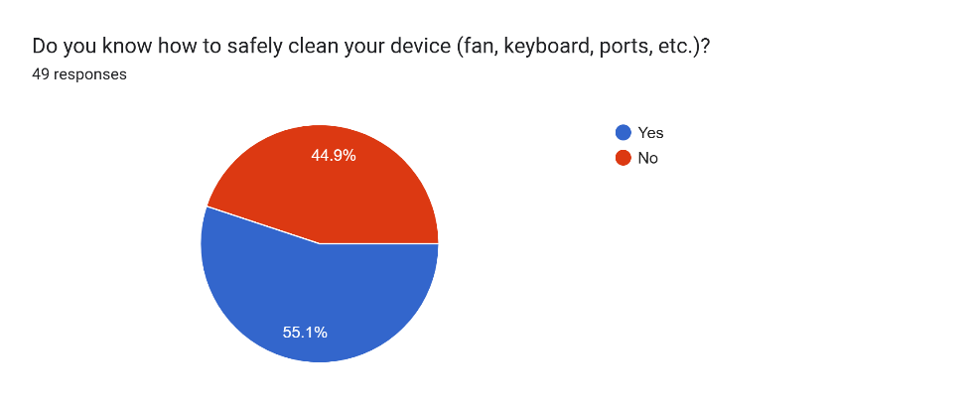
Figure 12: Awareness of Safe Device Cleaning Methods

The pie chart shows whether respondents know how to safely clean parts of their device such as the fan, keyboard, and ports. Out of 49 responses, 55.1% answered “Yes”, while 44.9% answered “No”. This means just over half of the users are aware of proper cleaning methods, while the rest may need guidance or reminders to avoid damaging their devices during maintenance.

Question 8:
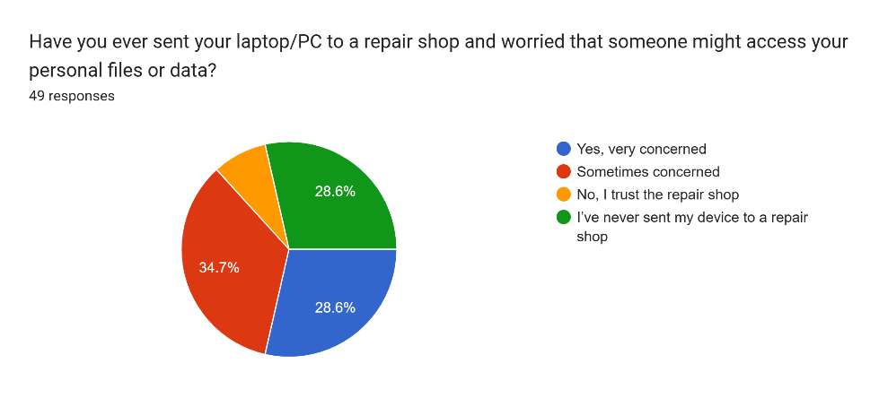
Figure 13: Data Privacy Concerns

The pie chart shows how respondents feel about the safety of their personal files when sending their laptop or PC to a repair shop. Out of 49 responses, 34.7% said they are sometimes concerned, and 28.6% are very concerned. Another 28.6% have never sent their device for repair, while 8.2% said they trust the repair shop. This suggests that many users feel uneasy about data privacy during repairs, which highlights the importance of secure handling and user control over personal data.

Question 9:
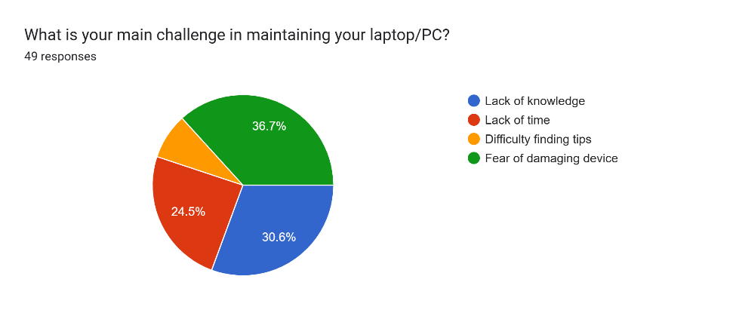
Figure 14: Main Challenges in Maintaining Devices

The pie chart shows the main difficulties users face when maintaining their laptops or PCs. Out of 49 responses, the most common challenge is fear of damaging the device (36.7%), followed by lack of knowledge (30.6%) and lack of time (24.5%). A smaller group (8.2%) mentioned difficulty finding tips. These results suggest that many users hesitate to perform maintenance due to uncertainty or concern about causing harm.

Question 10:
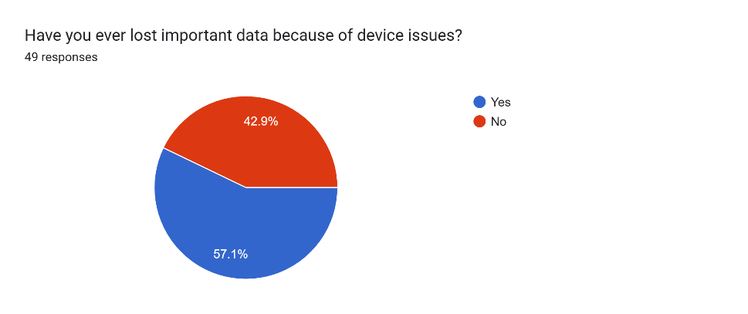
Figure 15: Experience of Data Loss Due to Device Issues

The pie chart shows whether respondents have ever lost important data because of problems with their laptop or PC. Out of 49 responses, 57.1% said “Yes”, while 42.9% said “No”. This means more than half of the users have experienced data loss, highlighting the importance of regular backups and reliable maintenance tools.

Question 11:
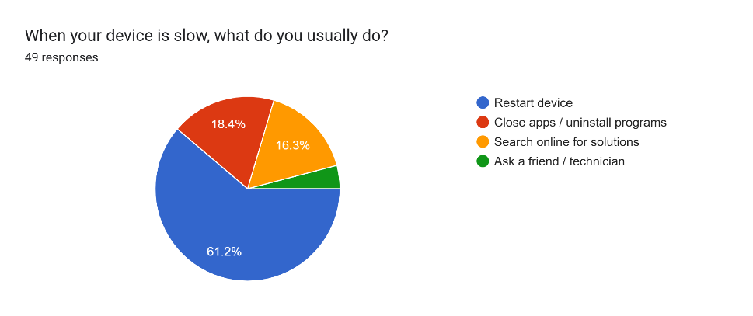
Figure 16: Actions Taken by Users During Device Slowdowns

The pie chart shows what users usually do when their laptop or PC becomes slow. Out of 49 responses, the majority (61.2%) choose to restart their device. Others try to close apps or uninstall programs (18.4%), search online for solutions (16.3%), or ask a friend or technician (4.1%). This suggests that restarting is the most common first step, while fewer users seek external help or detailed fixes

Question 12:
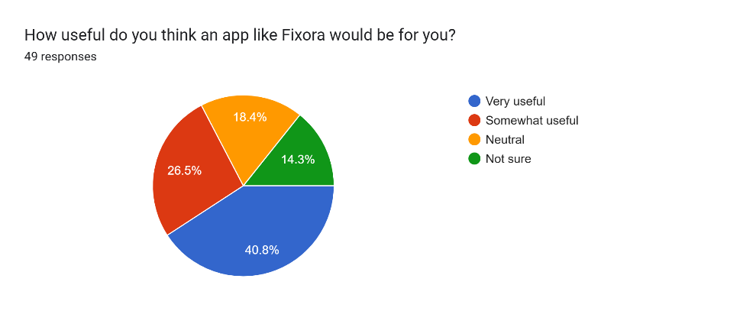
Figure 17: Expected Usefulness of the Fixora App

The pie chart shows how respondents feel about the potential usefulness of an app like Fixora. Out of 49 responses, 40.8% said it would be very useful, and 26.5% said it would be somewhat useful. Meanwhile, 18.4% chose neutral, and 14.3% were not sure. This suggests that most users see value in the app, with many expecting it to help with their device maintenance needs.

Question 13:
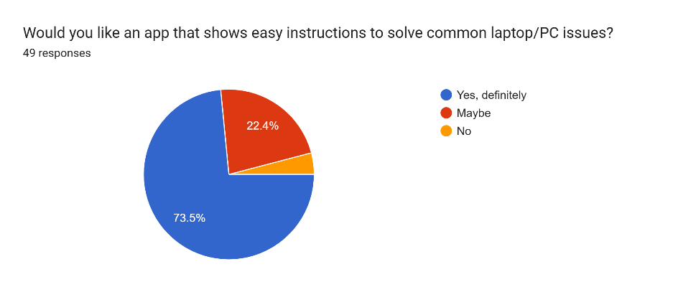
Figure 18: Demand for Simple Device Fixes App

The pie chart illustrates respondents’ opinions on having an app that provides simple instructions to solve common laptop or PC problems. Out of 49 respondents, 73.5% answered “Yes, definitely”, 22.4% selected “Maybe”, and only 4.1% chose “No”. The results show a high level of interest in a user-friendly troubleshooting app, suggesting that most users would welcome simple and accessible guidance for device issues.

Question 14:
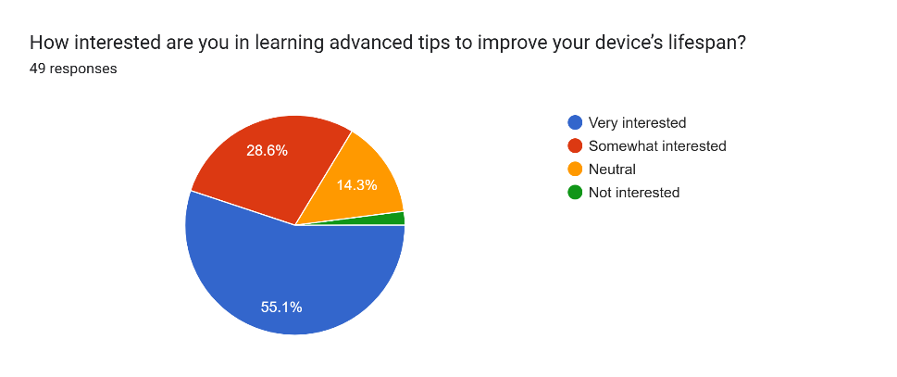
Figure 19: Interest in Learning Advanced Tips

The pie chart shows how interested users are in learning advanced tips to extend their device’s lifespan. Out of 49 responses, 55.1% said they are very interested, and 28.6% are somewhat interested. A smaller group (14.3%) chose neutral, while only a few respondents were not interested. This indicates that most users are keen to improve their device care knowledge, suggesting strong potential for educational content or app features focused on long-term maintenance.

Question 15:
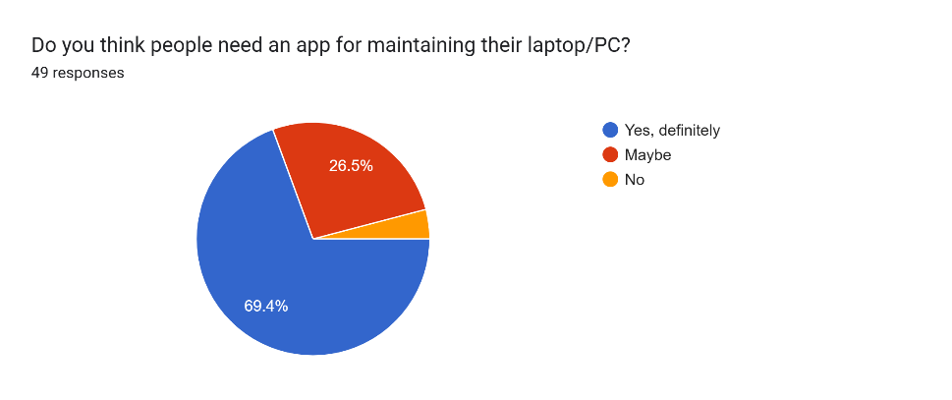
Figure 20: Need for a Maintenance App

The pie chart shows whether users think people need an app to help maintain their laptop or PC. Out of 49 responses, 69.4% said “Yes, definitely”, and 26.5% said “Maybe”. Only a small number said “No”. This shows strong support for a maintenance app, with most users seeing it as a helpful tool.

Question 16:
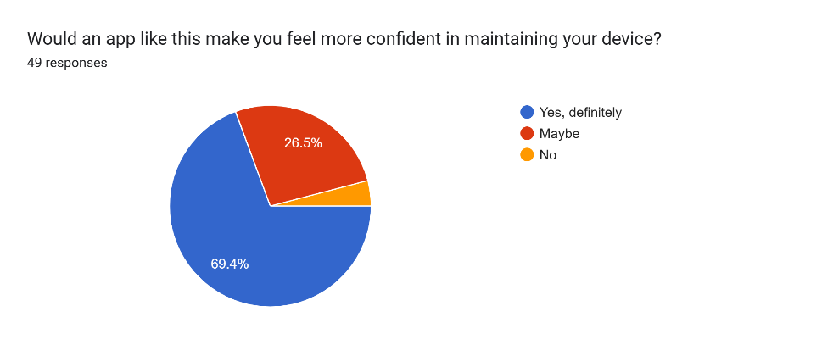
Figure 21: Confidence Increase with App Support

The pie chart shows whether users feel more confident maintaining their device if they had an app to guide them. Out of 49 responses, 69.4% said “Yes, definitely”, and 26.5% said “Maybe”. Only a few respondents said “No”. This suggests that most users believe an app could help them feel more capable and secure when handling device issues.

Question 17:
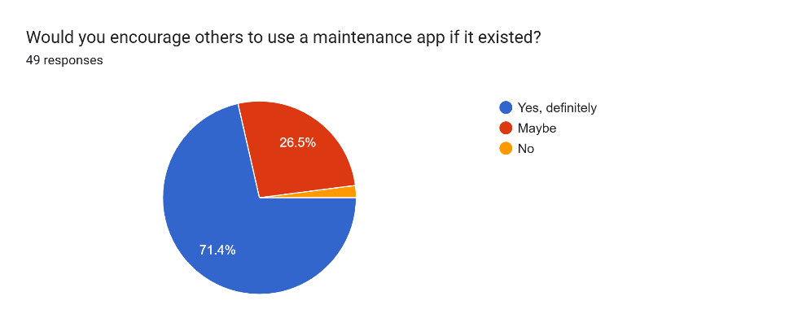
Figure 22: Willingness to Recommend the App

The pie chart shows whether users would encourage others to use a maintenance app. Out of 49 responses, 71.4% said “Yes, definitely”, and 26.5% said “Maybe”. Only a small number said “No”. This suggests that most users not only see value in the app for themselves but also believe it could help others. The strong positive response reflects good potential for user-driven promotion if the app is launched.

ANALYSIS AND DISCUSSION

The survey findings provide clear insights into user needs and preferences for a laptop and PC maintenance app. The sample group mainly consisted of young adults, and most respondents reported experiencing common issues such as overheating, slow performance, and concerns about data privacy when sending devices for repair. While some users attempt basic maintenance on their own, their confidence and knowledge remain limited, highlighting the need for simple guidance and safe solutions.

Most respondents believe that an app like Fixora would be useful, with over 70% expressing definite interest in troubleshooting features and advanced tips to help extend device lifespan. Many users also indicated that such an app would increase their confidence in maintaining their devices, and a large number stated they would recommend it to others, showing strong potential for user adoption.

Although the survey did not directly focus on technical aspects such as app security or performance, the presence of a small group of hesitant users suggests the importance of clear information, a simple interface, and trust-building elements such as data protection and reliable performance. In conclusion, the survey results show strong potential for Fixora as a user-friendly and educational maintenance app that addresses common user concerns and supports everyday device care.

RECOMMENDATIONS

Based on the survey results, several suggestions can help in developing the Fixora maintenance app. The app should focus on providing simple step-by-step instructions for common laptop and PC problems, as most users requested easy troubleshooting guidance to feel more confident in taking care of their devices. It is also important to make sure the app is secure, protects user data, and runs smoothly, since users are concerned about safety and reliability.

Including tips and advice on how to extend device lifespan will add extra value, as many respondents showed interest in learning more advanced maintenance practices. The app can also include features that make users feel confident, such as clear explanations, simple guides, and possibly small interactive elements to make maintenance tasks easier to follow.

Finally, because many users said they would recommend the app to others, adding features that encourage sharing, like referral rewards or a community section, could help spread the app and increase adoption. Overall, these suggestions highlight the need to make the app simple, trustworthy, and educational to meet user needs effectively.

CONCLUSION

The survey findings provide strong evidence that users see real value in a laptop/PC maintenance app like Fixora. Most respondents reported experiencing common device problems such as overheating, slow performance, and data privacy concerns when sending devices for repair. While some users attempt basic maintenance, many lack confidence and knowledge, which highlights the need for simple, step‑by‑step guidance. Most participants expressed definite interest in troubleshooting features and advanced tips to extend device lifespan, showing that users are motivated not only by convenience but also by learning how to care for their devices more effectively. Importantly, respondents believe that such an app would increase their confidence in handling maintenance tasks, and a large proportion indicated they would recommend it to others, suggesting strong potential for organic growth through word‑of‑mouth.

Although a small group of users expressed hesitation, this points to the importance of building trust through clear communication, a user‑friendly interface, and strong safeguards such as data protection and smooth, bug‑free performance. Addressing these concerns will be key to ensuring wider adoption. Overall, the survey highlights that Fixora has significant potential to fill a gap in the market by offering accessible, reliable, and educational support for everyday device care. By combining ease of use, confidence‑building features, and trust‑focused design, Fixora can position itself as a practical solution that meets the real needs of modern device users while encouraging long‑term engagement.

REFERENCES

- Rohn, S. (2025, October 3). 50 examples of useful in-app survey questions. Whatfix Blog
https://whatfix.com/blog/in-app-survey-questions/

- Simpletivity. (2022, November 29). How to Make a Google Form (Complete Beginner Tutorial) [Video]. YouTube.
https://www.youtube.com/watch?v=tLjbn_KAec0

